Equatio by Text Help

SVCC Installation Guide

Equatio offers several installation options for users. SVCC has purchased an Unlimited License for student and staff use. Users may install as many versions of Read&Write as they need for their devices.
- Equatio for Google Chrome
Equatio for Google Chrome is added through an extension. Search for the Equatio Extension at the Chrome Web Store. Learn to use the Equatio Extension in your Chrome browser at this link. (https://support.texthelp.com/help/getting-started-with-equatio)
- Equatio for Windows and Mac
Equatio for Windows and Mac is recommended for use with applications on the desktop of your computer including Microsoft Word. First, download the Equatio installer. (https://fastdownloads2.texthelp.com/equatio_desktop/version/index.html?_gl=1*1yq5ec4*_ga*MTk4MzUwMTAzMS4xNjYxOTcxNTA4*_ga_N9CG5GVJDK*MTY2NzgzMTg1Ny4xMi4xLjE2Njc4MzE5NTAuMC4wLjA.)
To install Equatio on a device complete the following steps:
Instructions | Screenshots
Navigate to the Texthelp Products page.  - https://academy.texthelp.com/equatio/ | 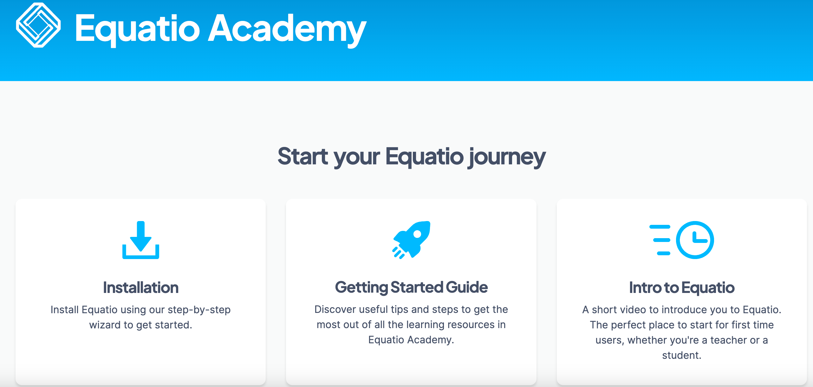
Instructions | Screenshots
Select the Installation option. | 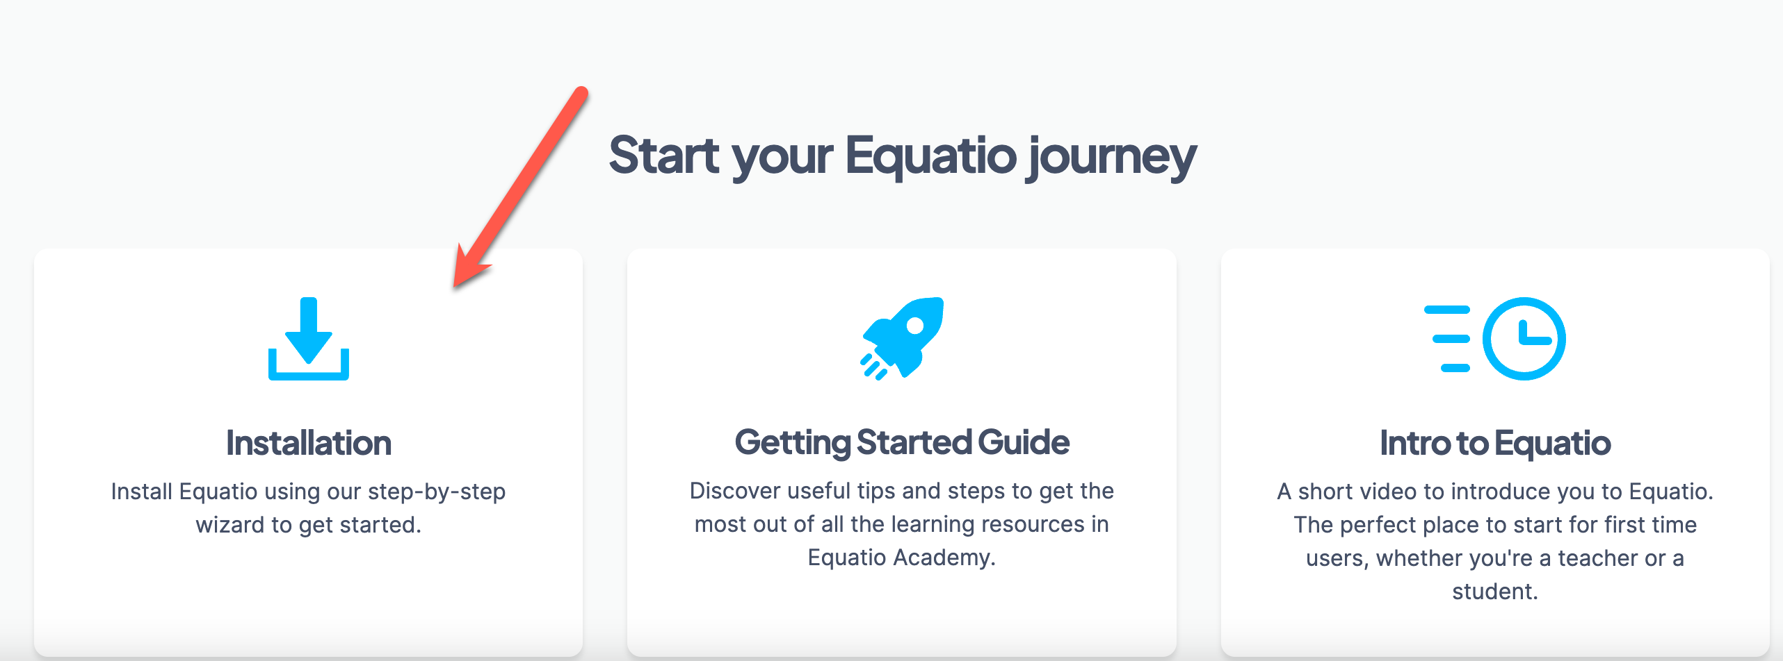
Select the “I don’t have a product code.” Option. Then select “Continue” | 
Instructions | Screenshots
Select the Products box for Equatio.  Then select “Continue”. | 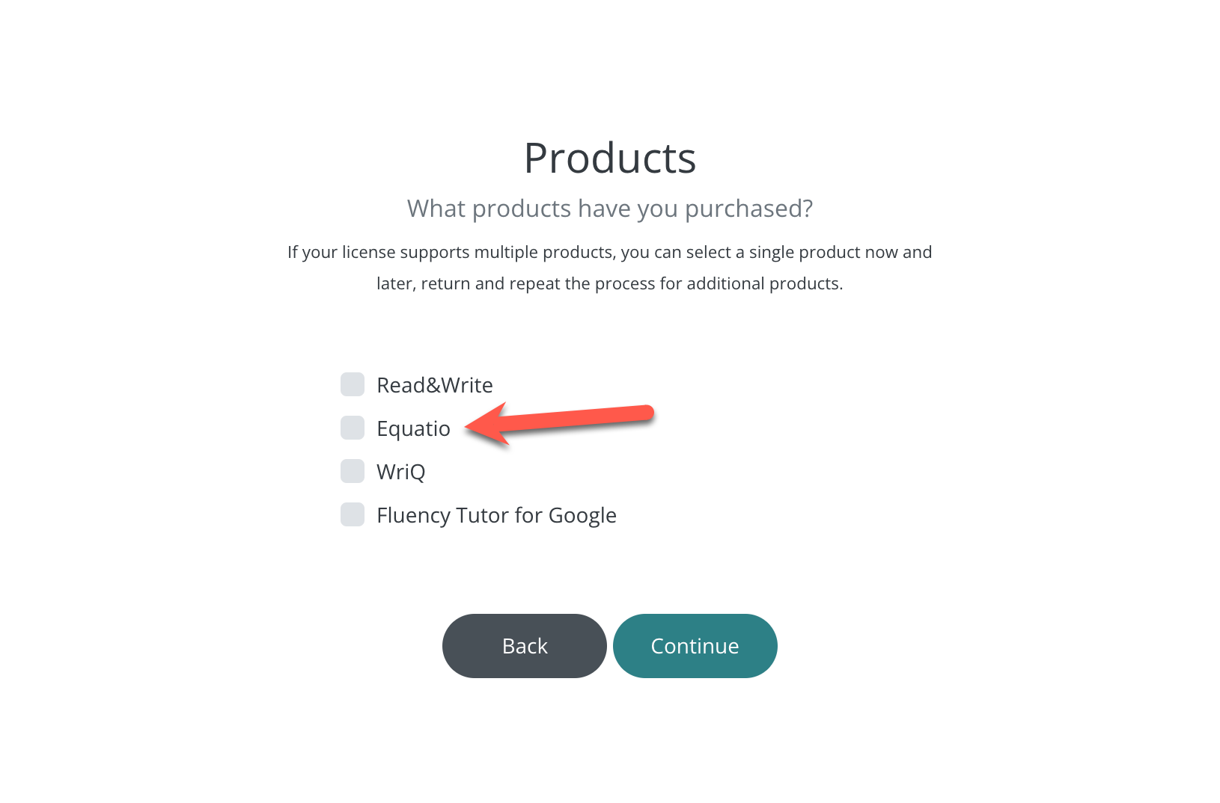
Instructions | Screenshots
From the dropdown menu, select one platform on which you wish to install the product. (Users may download additional platforms at a later time. Choose only one item from the menu at a time for successful installation.)  Select Continue at the bottom of the screen. | 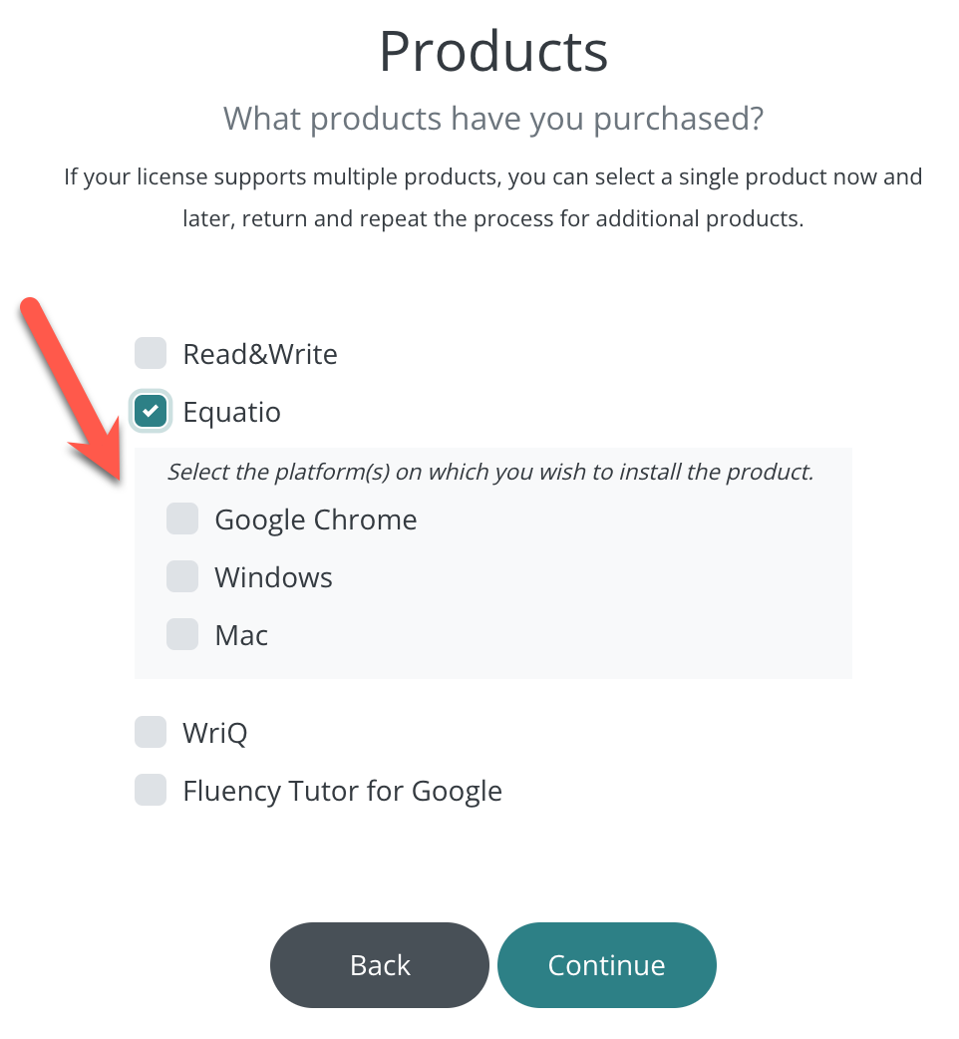
Licenses – Select Unlimited as the license type.  Select Continue at the bottom of the screen. | 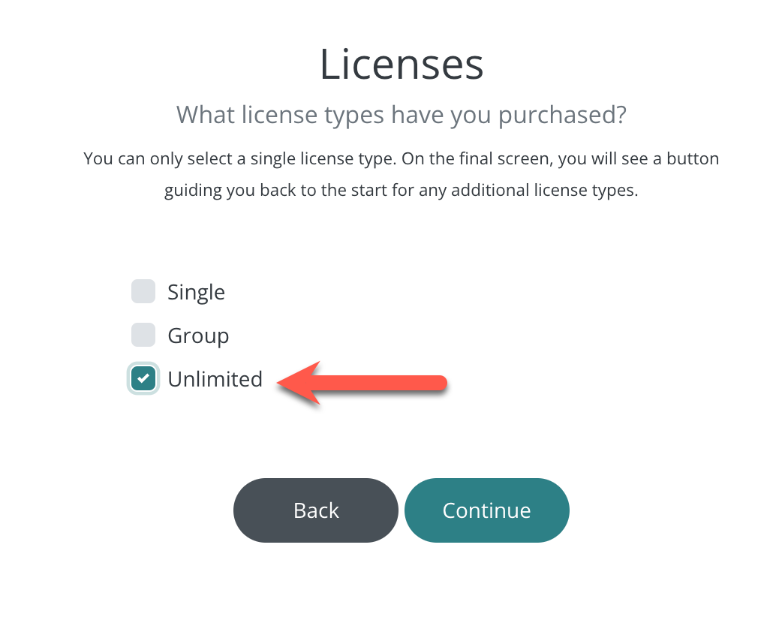
Instructions | Screenshots
Authentication: Select Google Workspace.  Select Finish at the bottom of the screen. | 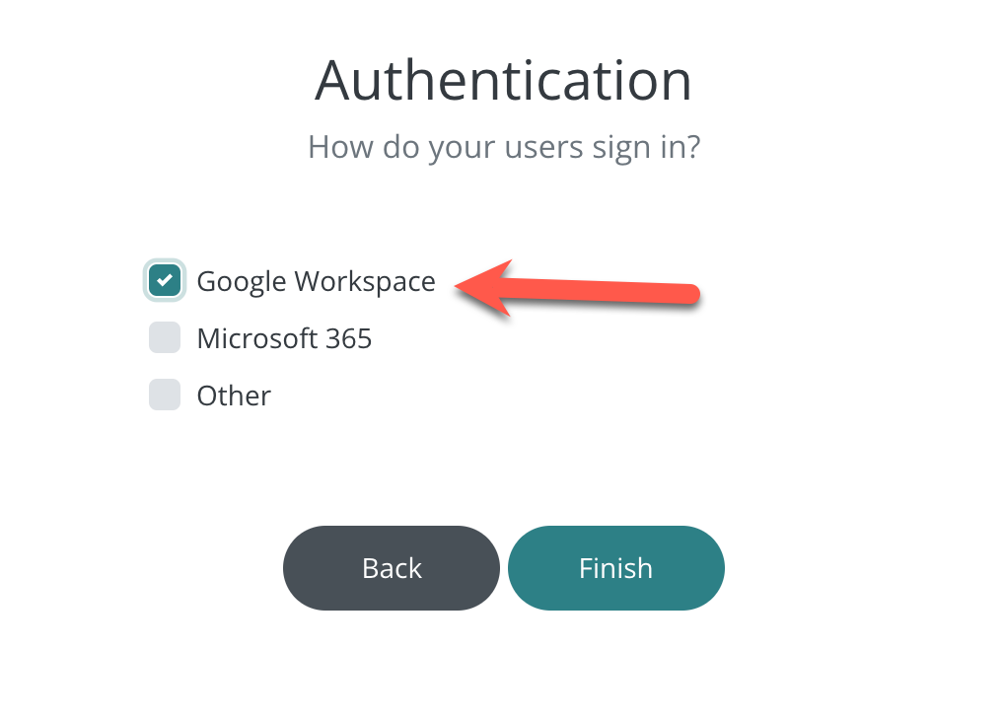

A new page will load where you will be provided the requested download file. Download and install the first provided file. When prompted to allow the app to make changes to your device, select Yes.
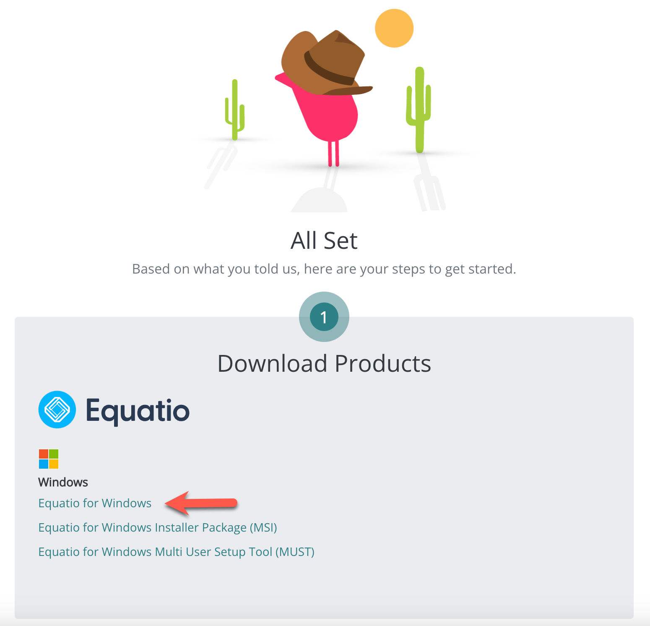
Equatio has also been integrated into the Rich Content Editor in Canvas.
Learn to use Equatio by selecting the reference guide for Google Chrome or Windows and Mac at the Texthelp Academy. (https://academy.texthelp.com/equatio/learning-resources/)

